B.Tech. BCSE497J - Project-I
CARECHAIN
Submitted in partial fulfillment of the requirements for the degree of
Bachelor of Technology
in
Computer Science and Engineering
(Specialization in Information Security)
by
23BCI0218 | ASHISH ANIL SIKARIA

Under the Supervision of
Dr. SELVI M
Associate Professor Grade 2
School of Computer Science and Engineering (SCOPE)

October 2026

DECLARATION
I hereby declare that the project entitled CareChain submitted by me, for the award of the degree of Bachelor of Technology in Computer Science and Engineering (Specialization in Information Security) to VIT is a record of bonafide work carried out by me under the supervision of Dr. Selvi M, Associate Professor Grade 2, School of Computer Science and Engineering.
I further declare that the work reported in this project has not been submitted and will not be submitted, either in part or in full, for the award of any other degree or diploma in this institute or any other institute or university.
Place : Vellore
Date : 27-10-2026
Signature of the Candidate
CERTIFICATE
This is to certify that the project entitled CareChain submitted by Ashish Anil Sikaria (23BCI0218), School of Computer Science and Engineering, VIT, for the award of the degree of Bachelor of Technology in Computer Science and Engineering (Specialization in Information Security), is a record of bonafide work carried out by him under my supervision during Fall Semester 2026-2027, as per the VIT code of academic and research ethics.
The contents of this report have not been submitted and will not be submitted either in part or in full, for the award of any other degree or diploma in this institute or any other institute or university. The project fulfills the requirements and regulations of the University and in my opinion meets the necessary standards for submission.
Place : Vellore
Date : 27-10-2026
Signature of the Guide
Examiner(s)

Head of the Department
B.Tech. Computer Science and Engineering (Information Security)
ACKNOWLEDGEMENTS
I am deeply grateful to the management of Vellore Institute of Technology (VIT) for giving me the opportunity and the resources to carry out this project. The laboratories, the library and the steady academic support of the university made it possible to turn an idea into a working prototype.
My sincere thanks to Dr. Jaisankar N, the Dean of the School of Computer Science and Engineering (SCOPE), for his encouragement and for the environment he has built around student projects.
I thank the Head of the Department for the guidance and the continuous support given to me during this semester. The feedback received in the reviews helped me to tighten the scope of the work and to test it properly.
I am especially thankful to my project guide, Dr. Selvi M, for her patient mentoring. Her questions during the weekly meetings pushed me to explain every design choice and to back each claim with a test, and that habit shaped this report.
Thank you all for your contributions and support.
Ashish Anil Sikaria
TABLE OF CONTENTS
Sl.No | Contents | Page No.
 | Abstract | vii
1. | INTRODUCTION | 1
 | 1.1 Background | 1
 | 1.2 Motivations | 1
 | 1.3 Scope of the Project | 1
2. | PROJECT DESCRIPTION AND GOALS | 2
 | 2.1 Literature Review | 2
 | 2.2 Research Gap | 3
 | 2.3 Objectives | 3
 | 2.4 Problem Statement | 3
 | 2.5 Project Plan | 3
3. | TECHNICAL SPECIFICATION | 4
 | 3.1 Requirements | 4
 | 3.1.1 Functional | 4
 | 3.1.2 Non-Functional | 4
 | 3.2 Feasibility Study | 5
 | 3.2.1 Technical Feasibility | 5
 | 3.2.2 Economic Feasibility | 5
 | 3.2.3 Social Feasibility | 5
 | 3.3 System Specification | 5
 | 3.3.1 Hardware Specification | 5
 | 3.3.2 Software Specification | 5
4. | DESIGN APPROACH AND DETAILS | 6
 | 4.1 System Architecture | 6
 | 4.2 Design | 6
 | 4.2.1 Data Flow Diagram | 6
 | 4.2.2 Use Case Diagram | 7
 | 4.2.3 Class Diagram | 7
 | 4.2.4 Sequence Diagram | 8
5. | METHODOLOGY AND TESTING | 9
 | 5.1 Module Description | 9
 | 5.2 Testing | 11
6. | PROJECT DEMONSTRATION | 11
7. | RESULT AND DISCUSSION (COST ANALYSIS) | 13
8. | CONCLUSION | 16
9. | REFERENCES | 16
 | APPENDIX A - SAMPLE CODE | 17
List of Figures
Figure No. | Title | Page No.
2.1 | Project implementation plan (Gantt chart) | 4
4.1 | CareChain four-layer system architecture | 6
4.2 | Level 1 data flow diagram | 7
4.3 | Use case diagram | 7
4.4 | Class diagram of the gateway data model and the smart contract | 8
4.5 | Sequence diagram: wallet sign-in, upload and access grant | 8
4.6 | Sequence diagram: dual-gate download and revocation | 9
5.1 | Flow of the dual-gate decrypt-and-stream method | 10
6.1 | Patient and doctor portals of the working prototype | 12
6.2 | Hospital administration console | 12
7.1 | Processing latency and disk residue | 13
7.2 | Integrity trials and post-revocation exposure | 13
7.3 | Gas used by each contract function | 14

List of Tables
Table No. | Title | Page No.
2.1 | Summary of the reviewed research papers | 2
2.2 | Summary of the reviewed patents | 2
3.1 | Functional requirements | 4
3.2 | Non-functional requirements | 4
3.3 | Software specification | 5
5.1 | Implementation status of each component | 10
6.1 | End-to-end run of the gateway API | 11
7.1 | Benchmark summary | 13
7.2 | Gas used and cost at a stated gas price | 14
7.3 | Feature comparison with related work | 15
7.4 | Aspects proposed for protection and their status | 15
List of Abbreviations
ABI | Application Binary Interface | IDF | Invention Disclosure Form
ACL | Access Control List | IPFS | InterPlanetary File System
AES | Advanced Encryption Standard | IV | Initialization Vector
API | Application Programming Interface | JWT | JSON Web Token
CID | Content Identifier | PHI | Protected Health Information
DApp | Decentralized Application | RAM | Random Access Memory
DFD | Data Flow Diagram | RBAC | Role-Based Access Control
EHR | Electronic Health Record | REST | Representational State Transfer
EIP | Ethereum Improvement Proposal | RPC | Remote Procedure Call
EVM | Ethereum Virtual Machine | SDG | Sustainable Development Goal
GCM | Galois/Counter Mode | TRL | Technology Readiness Level
GDPR | General Data Protection Regulation | TTL | Time To Live
HIPAA | Health Insurance Portability and Accountability Act
Symbols and Notations
K | 256-bit AES key, one per record | H( ) | Hash behind a content identifier
IV | 96-bit initialization vector | || | Concatenation of byte strings
P, C | Plaintext and ciphertext | σ | Wallet signature over the challenge
T | 16-byte GCM authentication tag | η | Single-use login nonce
ABSTRACT
Electronic health records are now kept almost entirely in hospital databases, and those databases have become easy targets. One leaked administrator password can expose every file, a patient cannot see who has opened a report, and a doctor whose permission was withdrawn can often keep reading because a server still holds a cached copy. CareChain is a patient-controlled record system built to close these gaps.
The system has four parts. A React web application gives patients, doctors and hospital administrators their own portals. A Node.js gateway signs users in with an Ethereum wallet, so there are no passwords, encrypts every uploaded file with AES-256-GCM and pins only the encrypted bytes to IPFS. A Solidity smart contract named MedicalRecord keeps the doctor registry, the patient-to-doctor permission table and an event log that nobody can rewrite. Files never go on the chain. Only the content identifier does, so the gas cost does not depend on file size.
The central idea of the project is the way a download is handled. Before a file is decrypted, the gateway passes two gates: the doctor's login session, and then the patient's permission together with the doctor's verified licence. The ciphertext is fetched, checked against its authentication tag and its on-chain address, decrypted in memory and streamed to the browser. Nothing readable is written to the server disk.
The prototype was tested at three levels. The contract is covered by an 11-case Hardhat suite, and direct measurement on a local EVM gave about 300,000 gas for the first record upload and about 46,000 gas for a permission grant. An end-to-end run of the gateway API showed that a doctor is refused before a grant, served after it and refused again right after a revoke, that a replayed login signature is rejected, and that one flipped ciphertext bit stops a download with no plaintext released. Algorithm benchmarks on 1,000 synthetic records recorded 0 bytes written to disk against about 424 KB for a disk-caching proxy, and all 375 tampering and spoofing trials were rejected while all 125 genuine requests were accepted.
The report also says plainly what is unfinished. The live contract query and the on-chain address comparison are specified and benchmarked but are not yet wired into the download route, and the gateway still holds the file keys. An invention disclosure form (IDF-B) naming four aspects for protection has been prepared, and the report sets each aspect beside what the prototype already does.
Keywords: electronic health records, blockchain, smart contract, IPFS, AES-256-GCM, wallet authentication, access control, patient data ownership.

CHAPTER 1
INTRODUCTION
1.1 Background
Hospitals moved from paper files to electronic health records (EHRs) over the last two decades, and the move has helped. A lab report can be read in seconds, a prescription history follows the patient, and a scan taken in one city can be reviewed in another. The cost of that convenience is that a hospital's whole history of patients now sits in a few central databases, usually run by the hospital or by a cloud vendor on its behalf.
Two ideas from outside healthcare offer a different way to build this. A blockchain such as Ethereum is a shared ledger that no single party can edit, and it can run small programs called smart contracts that decide who may do what. The InterPlanetary File System (IPFS) [14] stores files by the hash of their content, so a file's address changes if even one bit of it changes. Used together, a chain can hold the rules and the history, and IPFS can hold the bulky data. CareChain applies this split to medical records and then adds the parts that most published designs leave open: what the server does at the moment a file is decrypted, and how a doctor's licence is checked.
1.2 Motivations
Four everyday problems motivated the project, and each one shows up in the code that most record systems ship with.
- One database holds everything. If an attacker or a careless administrator reaches the database and its keys, every patient is exposed at once.
- The patient has no say after the first consent. A patient can rarely see who opened a report, and a revoked permission often takes effect only when a cache expires.
- Servers leave copies behind. A gateway that downloads a file, decrypts it and then serves it often writes the plaintext to a temporary folder. Those copies can be recovered later.
- Any doctor account can receive a record. If the system does not check that a doctor is licensed at the time of access, an expired or fake account can be trusted by mistake.
CareChain was designed so that each of these four problems has a specific, testable answer, and the testing chapters measure those answers instead of only describing them.
1.3 Scope of the Project
The project covers the design, the implementation and the testing of a working prototype. It includes the MedicalRecord smart contract with its unit tests, a gateway that handles wallet sign-in, encryption, IPFS pinning and download, role-based web portals for patients, doctors and a hospital administrator, and a set of experiments that measure the security effects claimed for the design. An invention disclosure form (IDF-B) was also prepared from the same work. It titles the invention "CareChain: A Decentralized System for Secure Medical Record Storage and Real Time Doctor Access Control with In Memory Streaming" and places it in healthcare information systems, data security, blockchain technology and decentralized cloud storage.
Several things are outside the scope. The prototype has not been connected to a real hospital information system, it runs on a local chain and test networks and not on a production network, and it has been tried only with synthetic records. Key wrapping to doctor public keys, zero-knowledge proofs and an emergency override are noted as future work in Chapter 8.
CHAPTER 2
PROJECT DESCRIPTION AND GOALS
2.1 Literature Review
The literature on blockchain-based health records is large, so the review follows one question: for each work, who can read a file after the patient has changed a permission, and what does the server do at the moment of decryption? Table 2.1 summarises the research papers and Table 2.2 the patents that were studied for the invention disclosure form.
Table 2.1: Summary of the reviewed research papers
Work | Approach | Strength | Limitation for this project
Azaria et al. (MedRec), 2016 [1] | Ethereum smart contracts manage permissions and give patients a tamper-resistant log. Records stay in provider storage. | Foundational access-control design with a patient-visible log. | Storage stays with providers; no live doctor licence check before decryption.
Xia et al. (MeDShare), 2017 [2] | Blockchain-based sharing and provenance of records between cloud providers. | Strong audit and tracking of every access. | Focus is provider-to-provider sharing, not patient-held grants.
Dubovitskaya et al., 2017 [3] | Permissioned blockchain with encryption for sharing cancer-care records. | Fine-grained sharing inside a consortium. | Needs a consortium network and heavier setup.
Shahnaz et al., 2019 [4] | Ethereum smart contract with off-chain IPFS storage and role-based access. | Keeps large files off the chain. | Does not describe server behaviour at decryption time.
Reen et al., 2019 [5] | Permissioned Ethereum, symmetric and asymmetric cryptography, IPFS storage, patient grant or revoke of hospital access. | Closest in storage design: encrypted records on IPFS. | Access is managed at hospital level; no licence registry, no dual integrity check, no RAM-only decrypt step.
Pilares et al., 2022 [6] | Reviews 65 blockchain EHR proposals, finds 14 recurring challenges and proposes EHRChain on Hyperledger Sawtooth and IPFS. | Confirms the value of combining blockchain with IPFS. | Stays at framework level; leftover decrypted files and licence re-checks are not addressed.
Romel et al., 2025 [7] | Per-patient Ethereum contract, patient-signed time-limited permissions, off-chain encrypted FHIR data. | Reports about 78,000 gas per grant and under 1.5 s access to a 1 MB record. | Silent on plaintext saved on intermediate servers and on provider verification.
Kenaza et al., 2026 [8] | Private Hyperledger blockchain with IPFS; contracts give patients exclusive control of records. | Interoperability with existing provider systems. | Private network; no public wallet login, no per-request live query, no zero-disk streaming.

Table 2.2: Summary of the reviewed patents
Patent | Description | Relevance to this work
US 12,235,984 B1 [9] | Blockchain architecture where patients own data and can revoke doctor permissions, with an immutable audit log. | Closest existing system. It does not address server data leakage during streaming, nor an active licence check at the moment of decryption.
US 11,244,059 B2 [10] | Blockchain for managing access to medical data. | Separates the access check from decryption, so servers can serve old or cached data.
US 12,292,997 B2 [11] | Authentication protocol for sharing records between hospitals using blockchain. | Hospital-to-hospital sharing with server brokers; CareChain lets patients share directly with verified doctors using wallet signatures.
CN 112863629 B [12] | Medical record storage combining IPFS and blockchain logs. | Lacks live doctor licence verification and the dual integrity check.
US 11,862,304 B1 [13] | Patient-authorized storage and access system; a patient master index is checked and a blockchain transaction grants access. | Authorization is enforced when a transfer is requested. No live check at decryption and no in-memory streaming.

Three points come out of this survey. First, putting permissions on a chain and files on IPFS is well established, so it cannot be the novelty. Second, almost every work treats the access check and the decryption as separate events, which leaves a gap if permissions change in between. Third, the licence of the doctor is rarely part of the access decision.
2.2 Research Gap
Reading the works above against the real behaviour of a typical gateway, five gaps remained open.
- Check and decrypt are separate. A permission is checked when it is granted or when a page loads, but the decryption step trusts a cached answer. A revoked doctor can keep reading until the cache is refreshed.
- Plaintext touches the disk. A gateway that decrypts to a temporary file leaves readable data behind on the server.
- Integrity is checked in one place only. Many designs trust either the storage layer or the metadata layer, but an attacker can swap a pointer in one while leaving the other intact.
- Licence status is not part of access. A patient may share a record with an account that is unverified, or whose licence was withdrawn after the grant.
- Sign-in still depends on passwords in many prototypes. A stolen password database then defeats the rest of the design.
A limited prior-art search (Google Patents, arXiv and a few journals) did not find a work that combines a live permission and licence check, in-memory decryption with no disk write, and a two-part integrity check in one flow. This only means it was not found in a small search. It does not prove the combination is new, and a patent professional would need to confirm it.
2.3 Objectives
The project has five objectives, and each one is tied to a measurement used in Chapter 7.
- Give patients complete ownership of their health records, so that no hospital or doctor can view or decrypt a file without the patient's explicit, verifiable digital permission.
- Stop data leaks from intermediary servers, so that decrypted files stream through RAM and no plaintext file is saved on the server disk.
- Make revocation immediate: when a patient revokes a doctor, or the administrator revokes a licence, access should stop on the next request without waiting for a cache to clear.
- Verify file integrity, so that tampering, corruption or unauthorised changes are detected and blocked before delivery.
- Remove password-based breaches by using one-time wallet signature challenges.
The work supports UN Sustainable Development Goal 3 (good health and well-being), because it makes records safer to carry and share, and Goal 9 (industry, innovation and infrastructure), because it tests a resilient design for health data. The IDF records the technology readiness level as TRL 4, technology validated in a laboratory environment through extensive experimental evaluation, and this report uses the same level. The outcome targeted is a patent. The disclosure form has been prepared, and Section 7.6 sets its four claims beside the current state of the prototype.
2.4 Problem Statement
To design and build a record management system in which the patient, and not the hospital server, decides who can read a file; in which the permission and the doctor's licence are checked at the moment of decryption; in which decrypted data never reaches the server disk; and in which any alteration of a stored file or its address is detected before delivery. The design must keep the on-chain cost independent of file size and must be tested with measurements.
2.5 Project Plan
The work ran over 17 weeks of the Fall Semester 2026-27, starting on 6 July 2026. Figure 2.1 shows how the tasks overlapped and where the three reviews fell. The contract and the gateway were built first because the portals and the experiments depend on them, and the experiments and the disclosure form were left for the last weeks so that they could use the finished prototype.
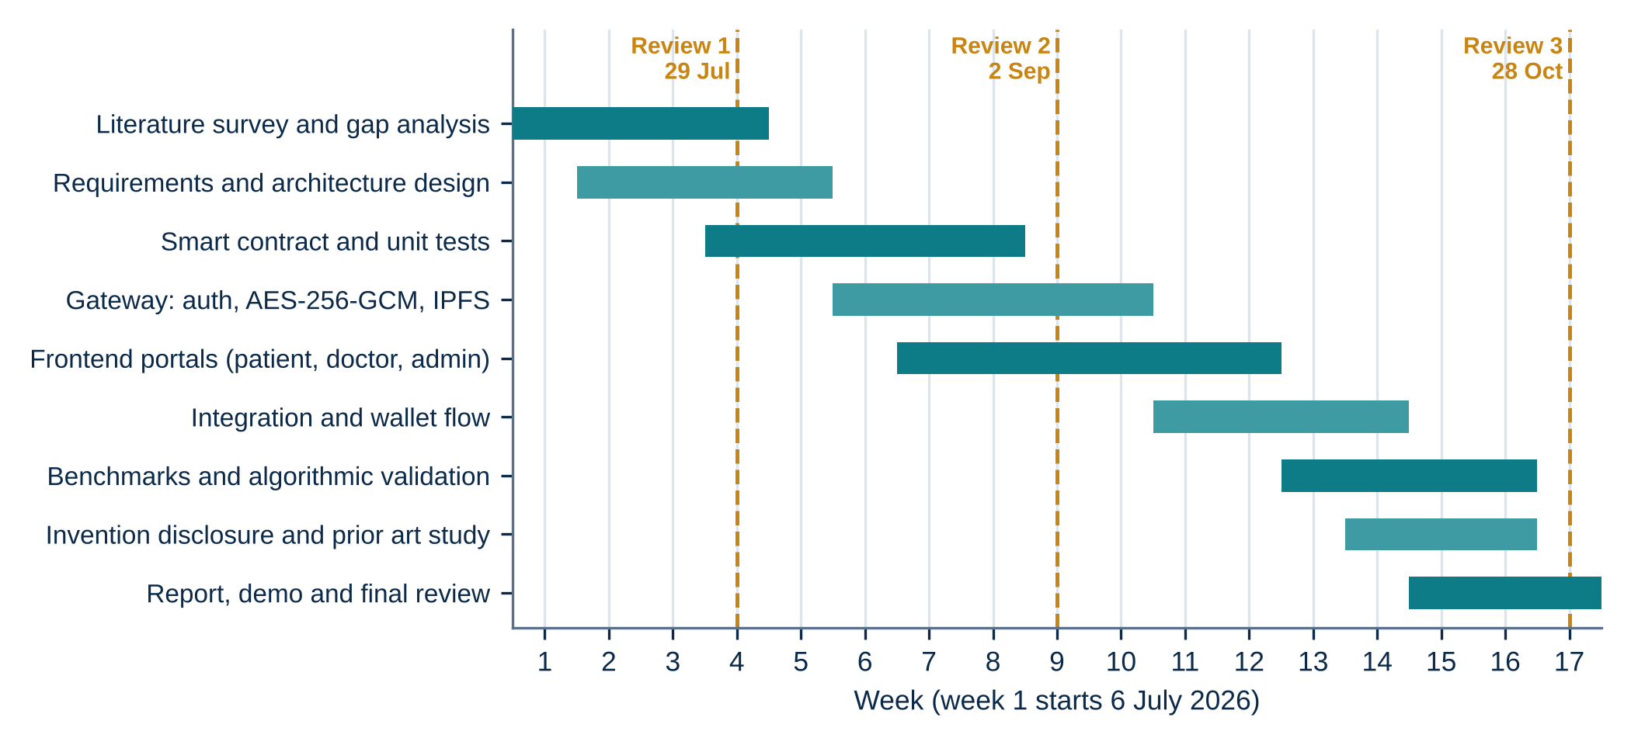
Fig. 2.1: Project implementation plan (Gantt chart)
CHAPTER 3
TECHNICAL SPECIFICATION
3.1 Requirements
3.1.1 Functional
Table 3.1 lists what the system must do. Each requirement was written so that it can be checked by a test or by a run of the prototype.
Table 3.1: Functional requirements
ID | Requirement
FR1 | A user signs in by signing a one-time challenge with an Ethereum wallet. No password is stored or asked for.
FR2 | A patient uploads a file. The system encrypts it with AES-256-GCM and stores only the ciphertext on IPFS.
FR3 | The record's title, type and IPFS address are registered, and the registration is visible as an on-chain event.
FR4 | A patient grants or revokes a doctor's access, and the change must apply to the next request.
FR5 | A doctor sees only the records shared with that doctor and can download and decrypt them.
FR6 | A hospital administrator verifies or revokes a doctor's licence, and the registry change affects all patients.
FR7 | Before any decryption the gateway checks the session, the permission and the licence, then the integrity of the file.
FR8 | Decrypted data is streamed from memory to the browser and is never written to the server disk.
3.1.2 Non-Functional
Table 3.2: Non-functional requirements
ID | Requirement | How it is met or measured
NFR1 Security | Files are unreadable without the key. Replayed or forged logins fail. | AES-256-GCM, random IV per file, nonce rotation (Sections 5.1 and 6).
NFR2 Integrity | Any change to a stored file or its address is detected. | GCM tag plus on-chain address (500 trials, Section 7.2).
NFR3 Performance | Gateway processing per file should stay in milliseconds. | Benchmarks in Section 7.1.
NFR4 Cost | On-chain cost must not grow with file size. | Only the CID is stored; gas measured in Section 7.3.
NFR5 Availability | Demo and development must run without external services. | In-memory store and mock CID fallback in the gateway.
NFR6 Compliance | Design should map to HIPAA technical safeguards and GDPR erasure. | Audit events, encryption, crypto-shredding by key deletion.
3.2 Feasibility Study
3.2.1 Technical Feasibility
Every part of the stack is mature and open source: Solidity and Hardhat for the contract, Node.js and Express for the gateway, MongoDB for metadata, Pinata for IPFS pinning and React for the portals. The whole prototype, including a local blockchain, runs on one laptop, and the repository can be started with a single command. The gateway also falls back to an in-memory store when no database is configured, which made testing possible without any external account.
3.2.2 Economic Feasibility
Only the content identifier and a few short strings go on the chain, so a record upload costs the same whether the file is 10 KB or 10 MB. Section 7.3 gives measured gas values. Pinning is offered free or at low cost by commercial IPFS services for small volumes, and all the software used is free. The main running cost in a real deployment would be the gas on a low-fee network and a small server for the gateway.
3.2.3 Social Feasibility
Patients gain a clear benefit, which is control over who can read their records, and hospitals gain a smaller liability because the gateway holds only encrypted files. Wallet sign-in will be unfamiliar to many people, so the interface keeps the steps short: connect, sign once, and use the dashboard. The design maps to the HIPAA technical safeguards for access control, audit and transmission security, and to the GDPR right to erasure through key deletion. This is an alignment of design, not a certification.
3.3 System Specification
3.3.1 Hardware Specification
A laptop or desktop with a four-core processor at 2.4 GHz or better (Intel Core i5 or AMD Ryzen 5 class), 8 GB of memory (16 GB recommended when a local Hardhat node runs beside the gateway and the portals), a 256 GB SSD with about 10 GB free, and a broadband connection for the IPFS gateway and any test network RPC.
3.3.2 Software Specification
Table 3.3: Software specification
Layer | Technology | Used for
Smart contract | Solidity 0.8.20, Hardhat 3, Chai | Doctor registry, permission table, events, unit tests
Gateway | Node.js 18+, Express 5, Multer, JWT, Mongoose 9 | Sign-in, upload, encryption, download, role checks
Storage | IPFS via Pinata, MongoDB (optional), in-memory store | Encrypted files, metadata, share list
Web client | React 19, React Router 7, Tailwind CSS 3.4, Ethers.js 6 | Patient, doctor and admin portals, wallet signing
Cryptography | AES-256-GCM, EIP-191 personal_sign, SHA-256 based CIDs | File encryption, login proof, content addressing
Networks | Hardhat local, Polygon Amoy, Ethereum Sepolia | Local testing and public test deployment
Tooling | Bun or npm workspaces, Docker Compose, Git | Install, run and package the project
CHAPTER 4
DESIGN APPROACH AND DETAILS
4.1 System Architecture
CareChain is organised in four layers, shown in Figure 4.1. The client layer holds the three portals and the wallet. The gateway layer verifies identity, applies role rules, encrypts and decrypts. The storage layer holds the encrypted files on IPFS and the metadata in a database. The blockchain layer holds the rules and the history.
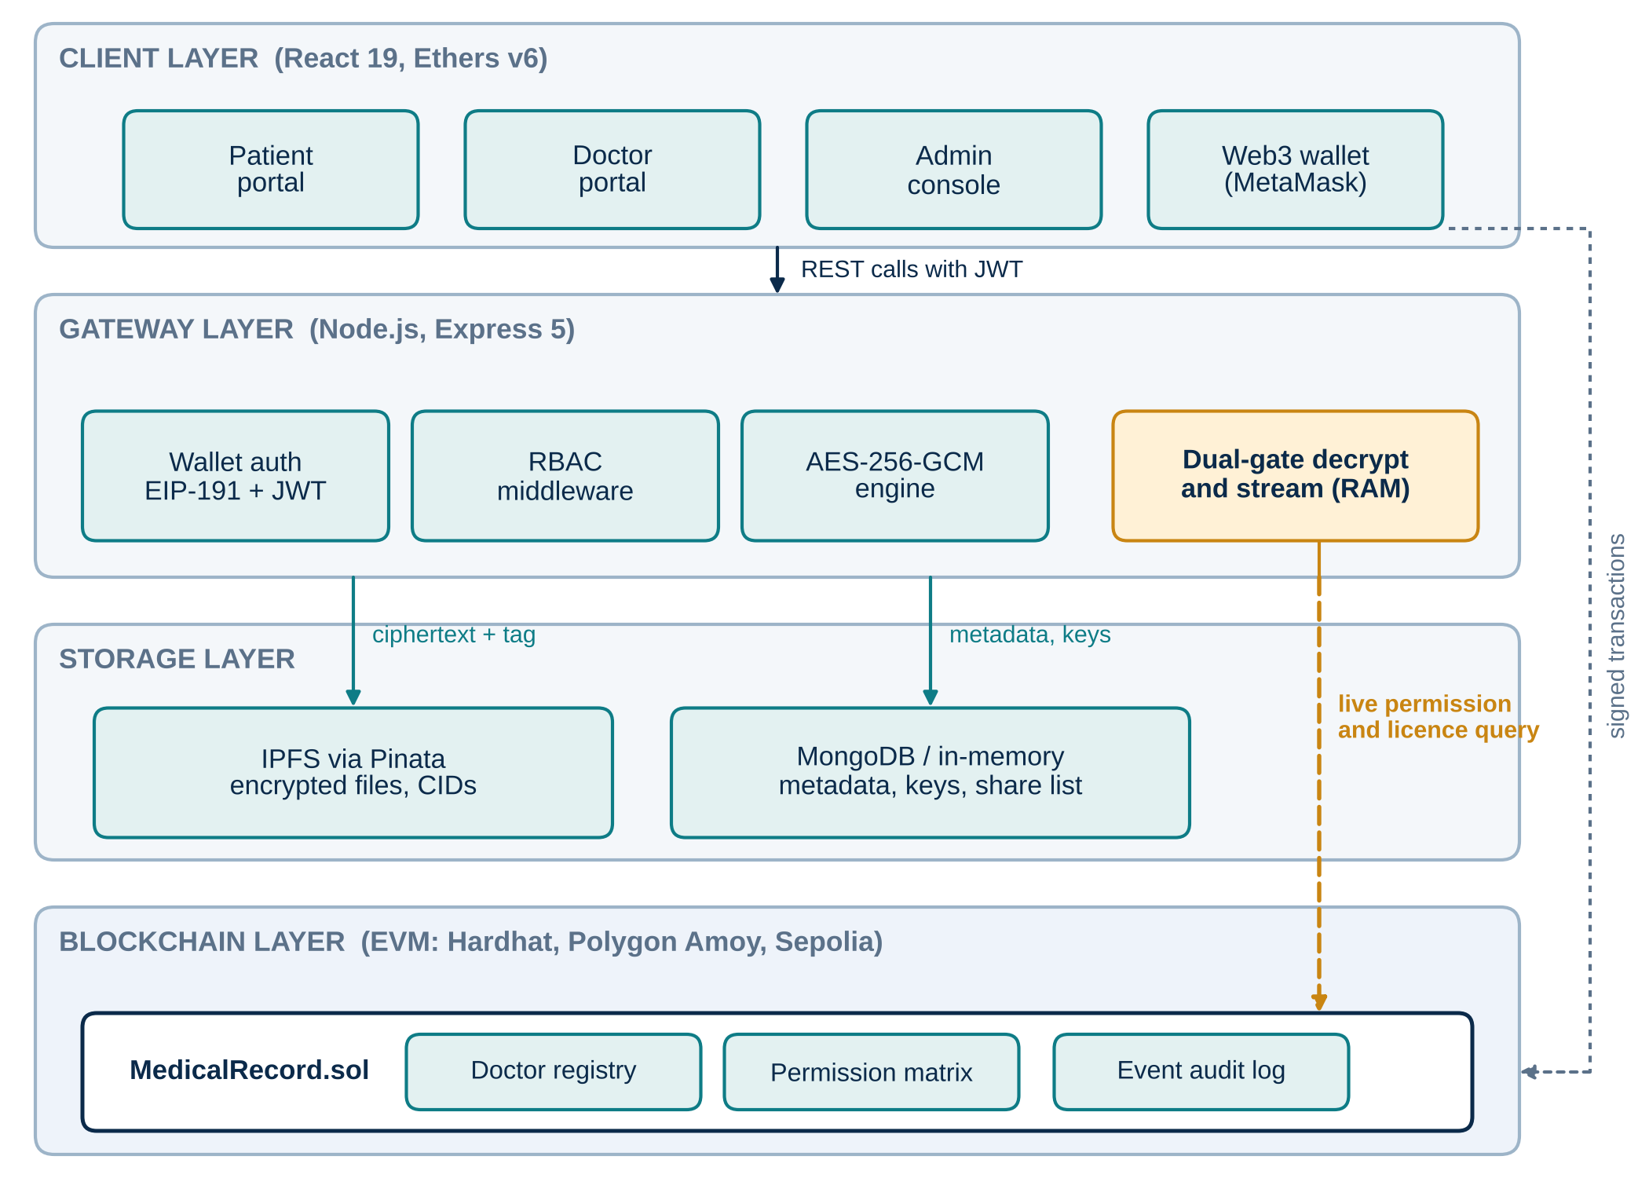
Fig. 4.1: CareChain four-layer system architecture
The split follows one principle: put on the chain only what must be tamper-evident and shared, and keep everything bulky or private off it. The contract stores the doctor registry, the permission table and the record pointers. The gateway stores the AES key, IV and tag for each file in its database next to the metadata. IPFS stores ciphertext only, so someone who reads the IPFS network sees random bytes. The dashed amber arrow in Figure 4.1 is the new element of this work: the gateway asks the contract about permission and licence on each download, instead of relying on an earlier answer.
4.2 Design
4.2.1 Data Flow Diagram
Figure 4.2 shows the four processes of the system and the three data stores. Process 1.0 turns a wallet signature into a session. Process 2.0 encrypts a file and writes the ciphertext to IPFS and the key material to the gateway database. Process 3.0 records patient grants and administrator verifications. Process 4.0 answers a doctor's download by reading the contract, the database and IPFS, and returns a plaintext stream.
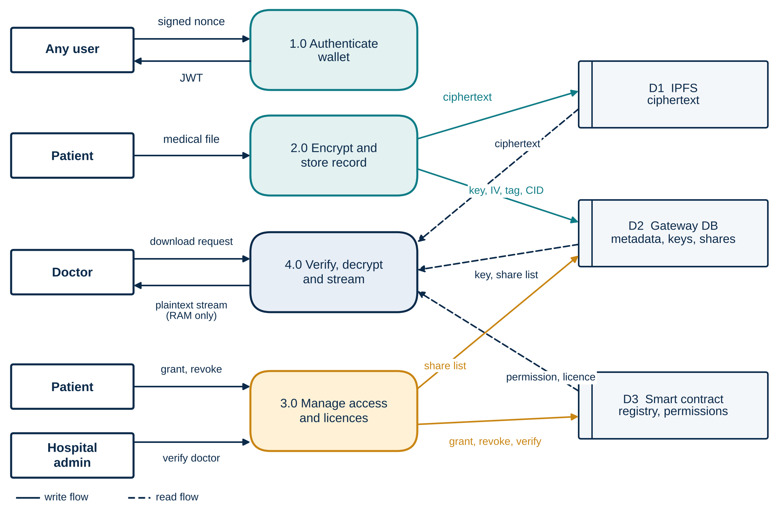
Fig. 4.2: Level 1 data flow diagram
4.2.2 Use Case Diagram
There are three actors. The patient uploads, views, grants and revokes. The doctor views shared records, downloads them, uploads notes and registers a profile. The hospital administrator verifies or revokes licences and watches network statistics. All three begin with the wallet sign-in use case.
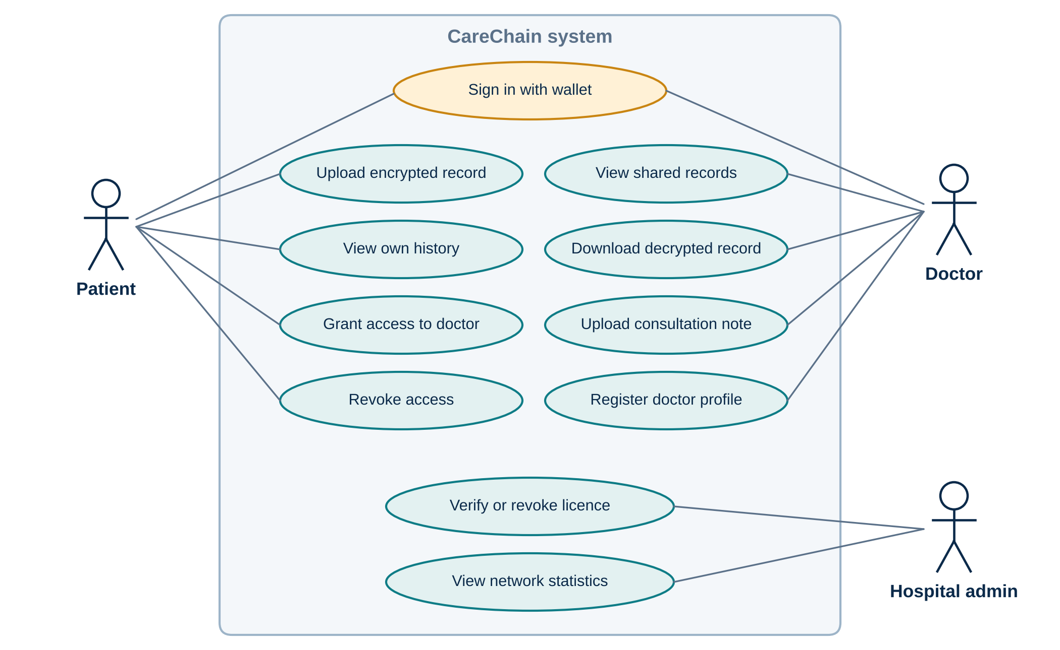
Fig. 4.3: Use case diagram
4.2.3 Class Diagram
Figure 4.4 shows the data model on both sides of the system. The gateway keeps a User (identified by wallet address, with a rotating nonce), a Record (with the CID, the key material and the share list) and a short-lived WalletChallenge for wallets that have not registered yet. The MedicalRecord contract keeps a doctor profile per doctor address, a record list per patient and a permission mapping from patient to doctor.
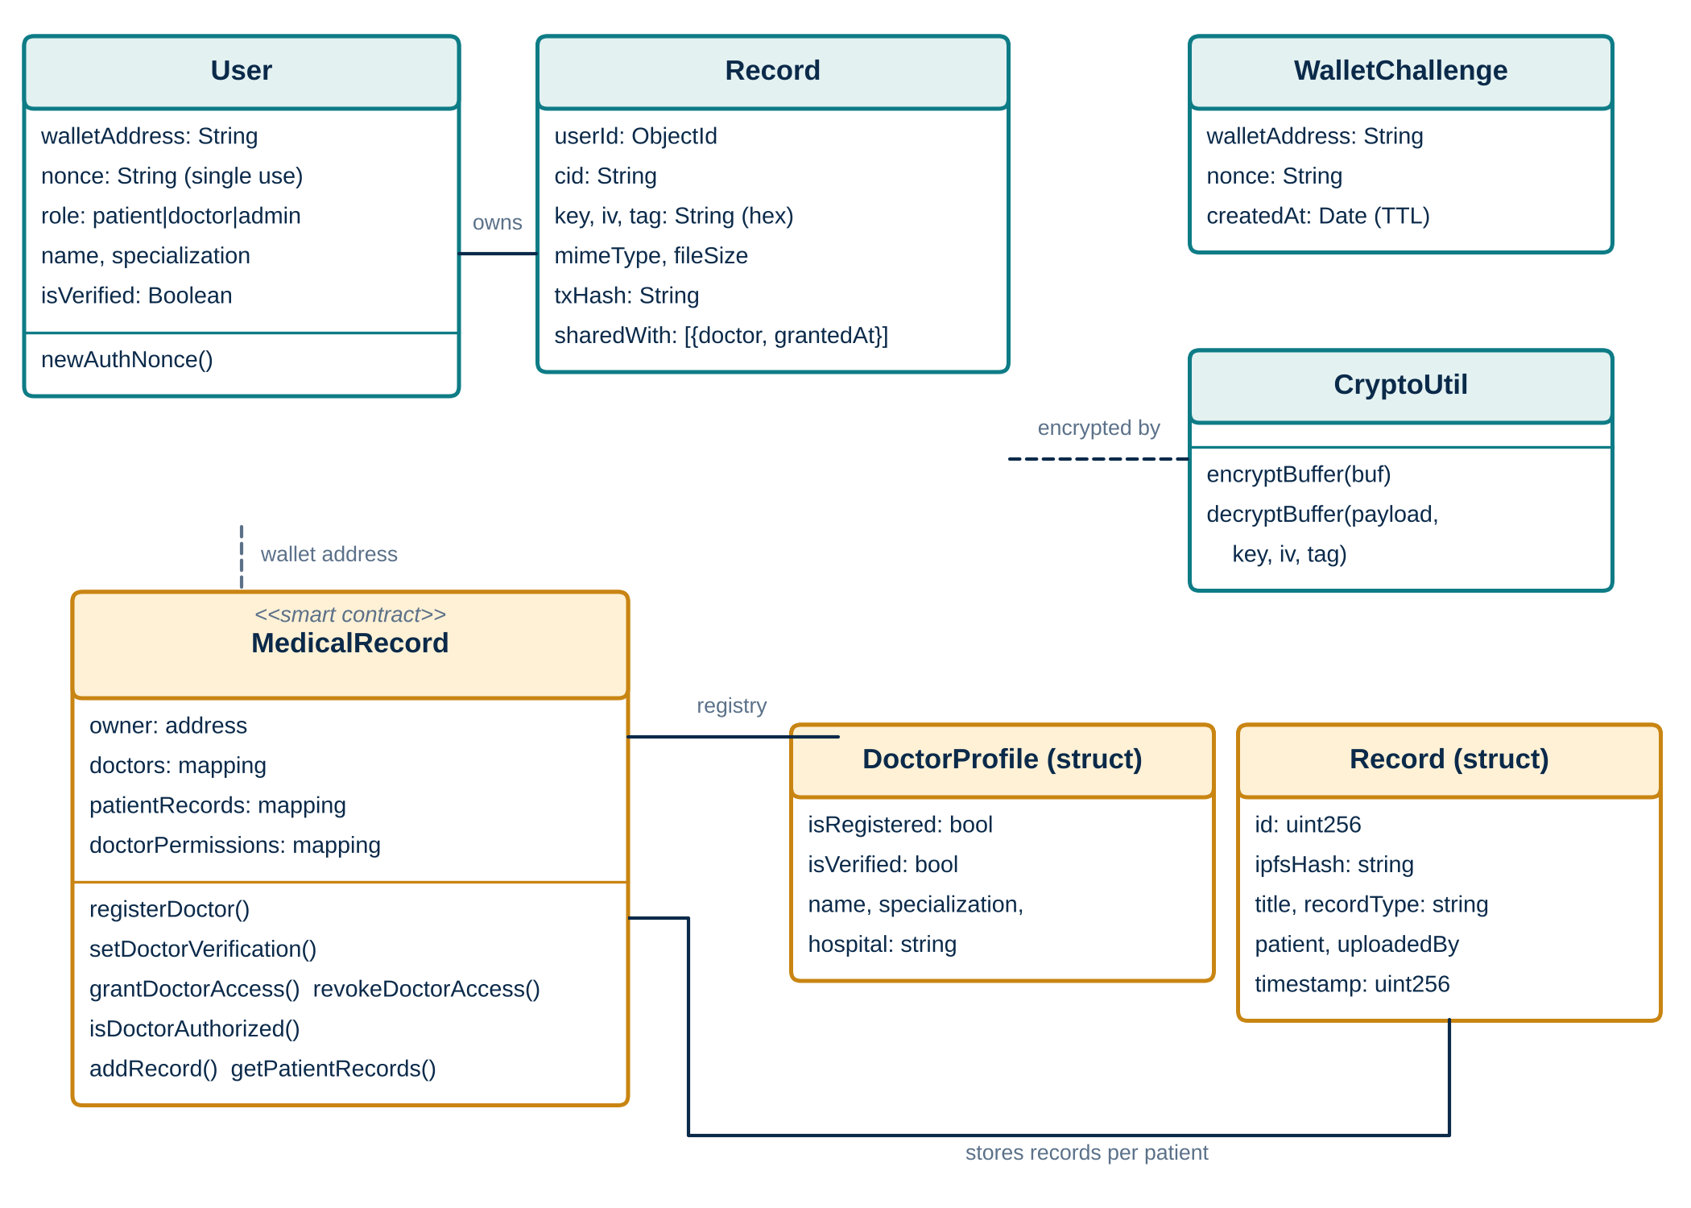
Fig. 4.4: Class diagram of the gateway data model and the smart contract
4.2.4 Sequence Diagram
Figure 4.5 follows a patient from sign-in to sharing. The signed challenge proves the wallet owner is present, the gateway encrypts and pins the file, and the patient's own wallet signs the transactions that register the record and grant access. Figure 4.6 then follows a doctor's download and a later revocation.
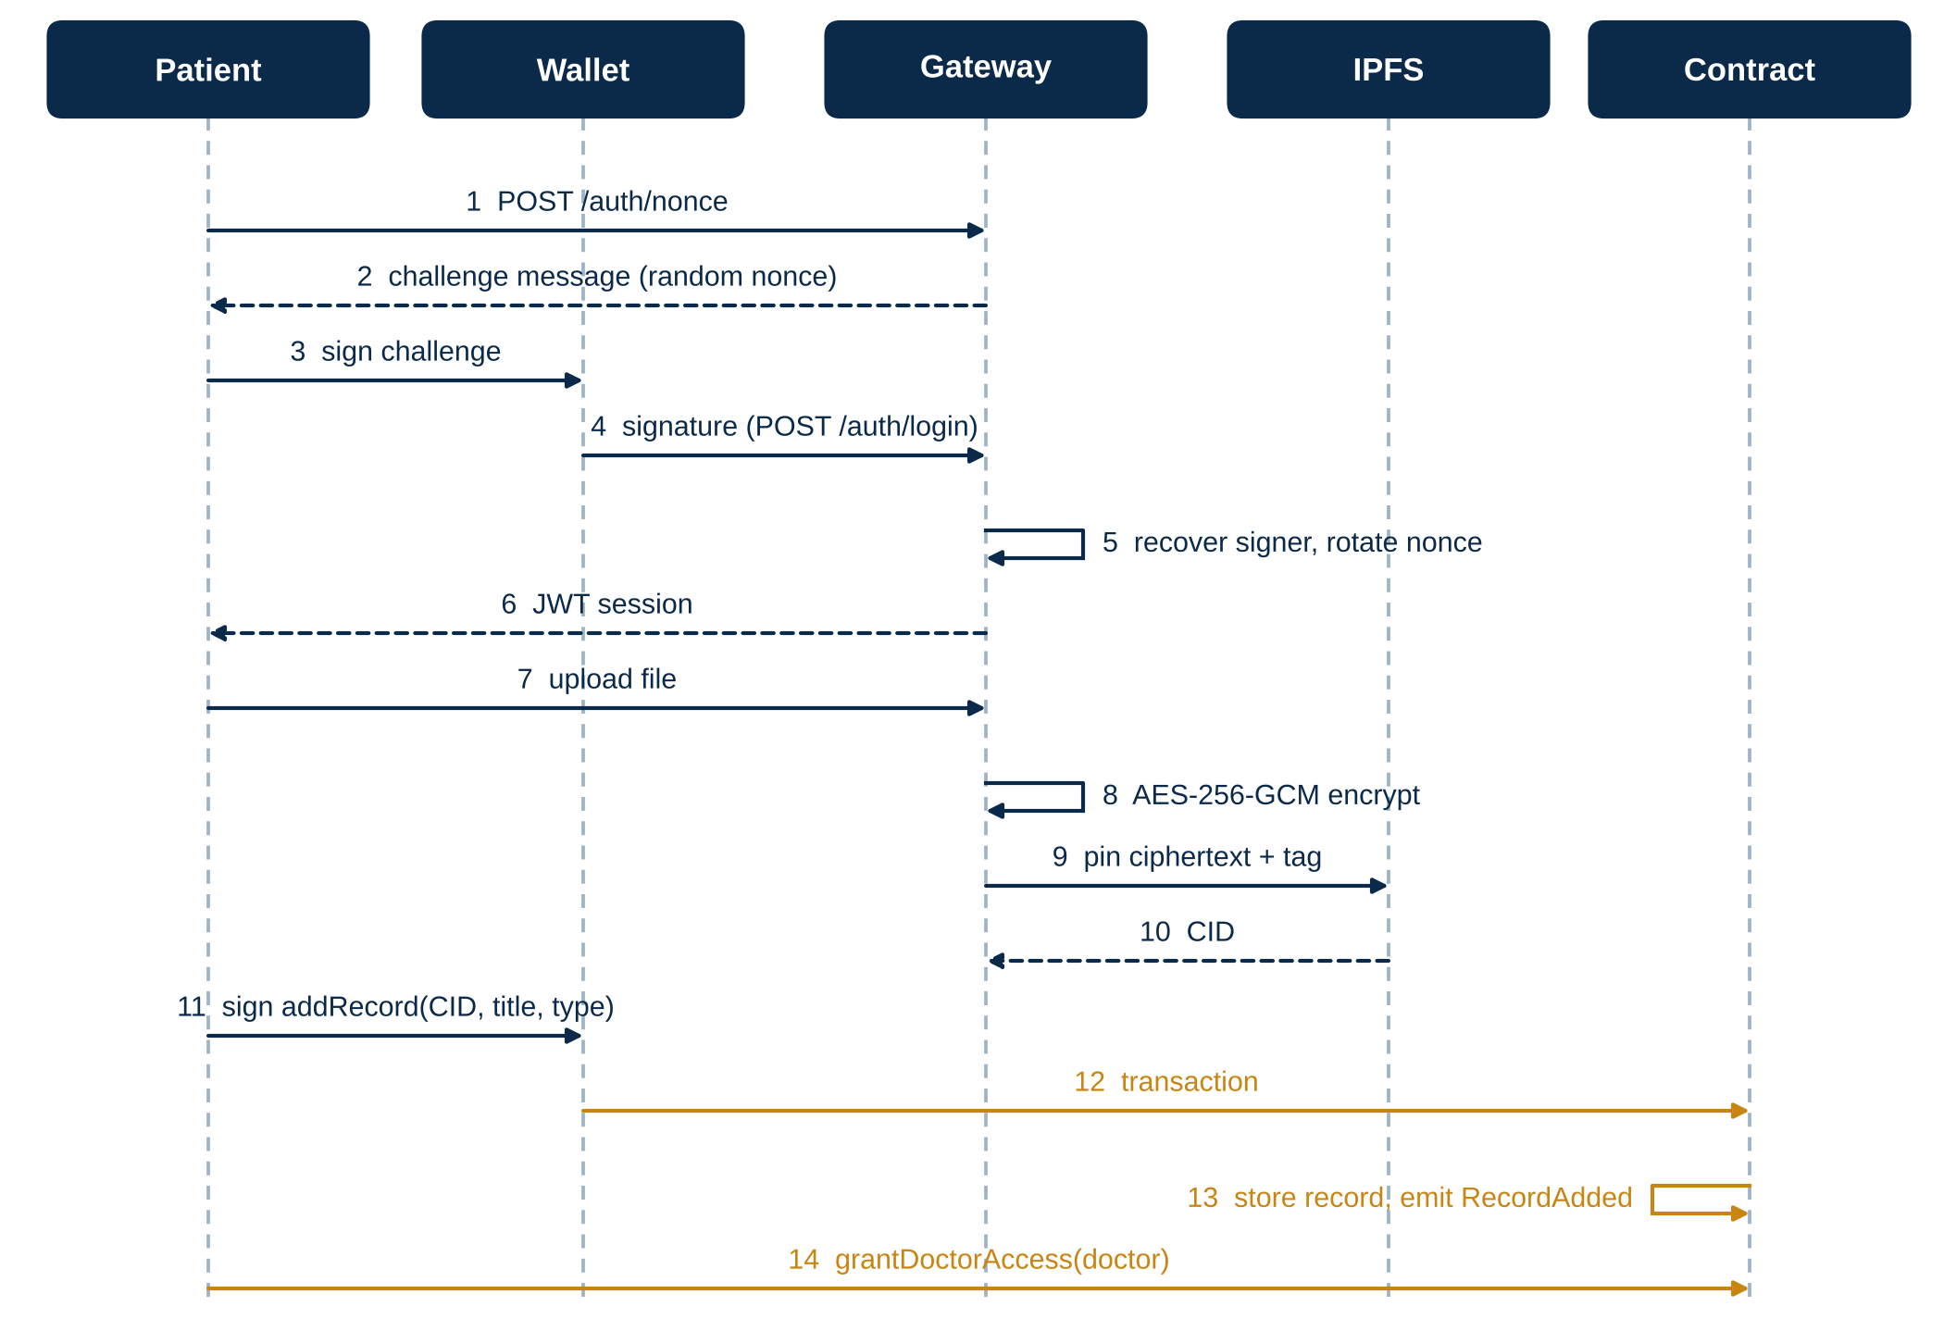
Fig. 4.5: Sequence diagram: wallet sign-in, upload and access grant
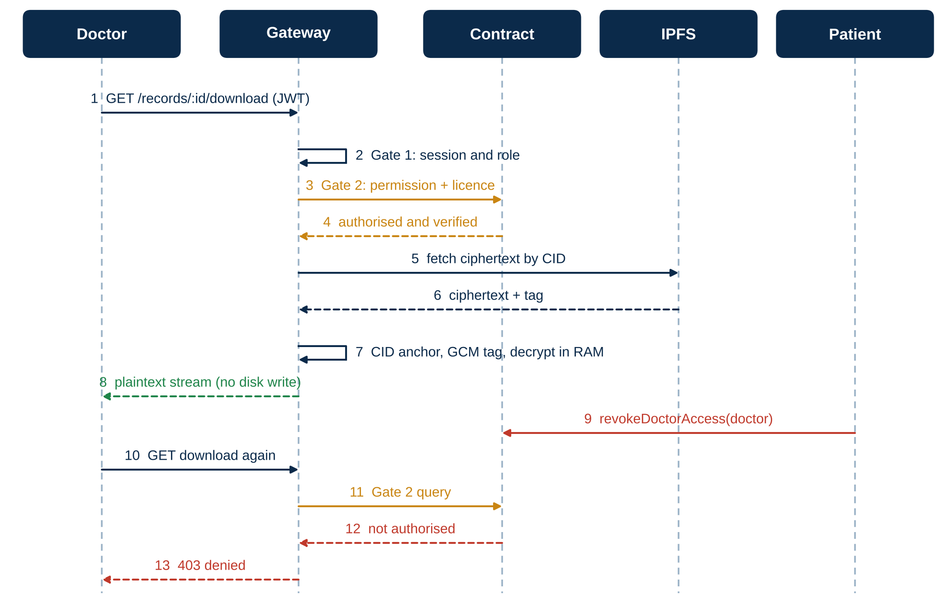
Fig. 4.6: Sequence diagram: dual-gate download and revocation
CHAPTER 5
METHODOLOGY AND TESTING
5.1 Module Description
The prototype is divided into six modules. The first five are described below, and the sixth is the portal layer shown in Chapter 6.
Module 1: MedicalRecord smart contract
The contract in contracts/MedicalRecord.sol is the shared source of truth. A doctor calls registerDoctor, which creates a profile with isVerified set to false. Only the owner address, which stands for the hospital authority, can call setDoctorVerification. A patient calls grantDoctorAccess or revokeDoctorAccess, which flips one entry in the mapping doctorPermissions[patient][doctor]. A record is added with addRecord, which stores the CID, title, type and uploader and emits a RecordAdded event. Every state change emits an event, so the history is complete. A patient cannot authorise their own address, and one patient's list is never visible to another.
Module 2: Passwordless wallet authentication
The gateway never stores a password. To sign in, a client asks POST /auth/nonce for a challenge. The reply is a readable message that contains a random 256-bit nonce and an issue time. The wallet signs it with personal_sign (EIP-191). The gateway recovers the signer with ethers.verifyMessage, checks that the recovered address matches, that the nonce matches and that the message is under ten minutes old, and then issues a JSON Web Token. The nonce is replaced straight away, so the same signature cannot be used twice. New wallets receive a short-lived pending challenge so they can register.
Module 3: Encryption and IPFS storage
When a file is uploaded, encryptBuffer creates a fresh 256-bit key K and a 96-bit IV with the operating system's random generator and encrypts the file with AES-256-GCM [15]. The result is a ciphertext C and a 16-byte tag T. In the notation of this report, (C, T) = AES-GCM-Enc(K, IV, P). Uploads are held in memory by Multer, never written to disk, and the payload C || T is pinned to IPFS, which returns the CID. The key, IV and tag are stored with the record metadata. When no Pinata token is set, the gateway creates a mock CID so the rest of the flow can still be tested.
Module 4: Dual-gate decrypt and stream
This is the module that carries the main idea. A download is allowed only when all of the following hold:
Allow(d, r) = Session(d) AND Permission(patient(r), d) AND Verified(d) AND CID(r) = Anchor(r) AND TagValid(C, T)
Gate 1 checks the doctor's JWT and role. Gate 2 asks the contract whether the patient has granted access and whether the doctor is a verified practitioner. If either gate fails, the request ends with 401 or 403 and the ciphertext is never fetched. Otherwise the gateway fetches the ciphertext from IPFS, compares the CID with the value anchored on the chain, lets AES-GCM verify the tag while decrypting, and sends the plaintext straight into the HTTP response from memory. Figure 5.1 shows the flow.
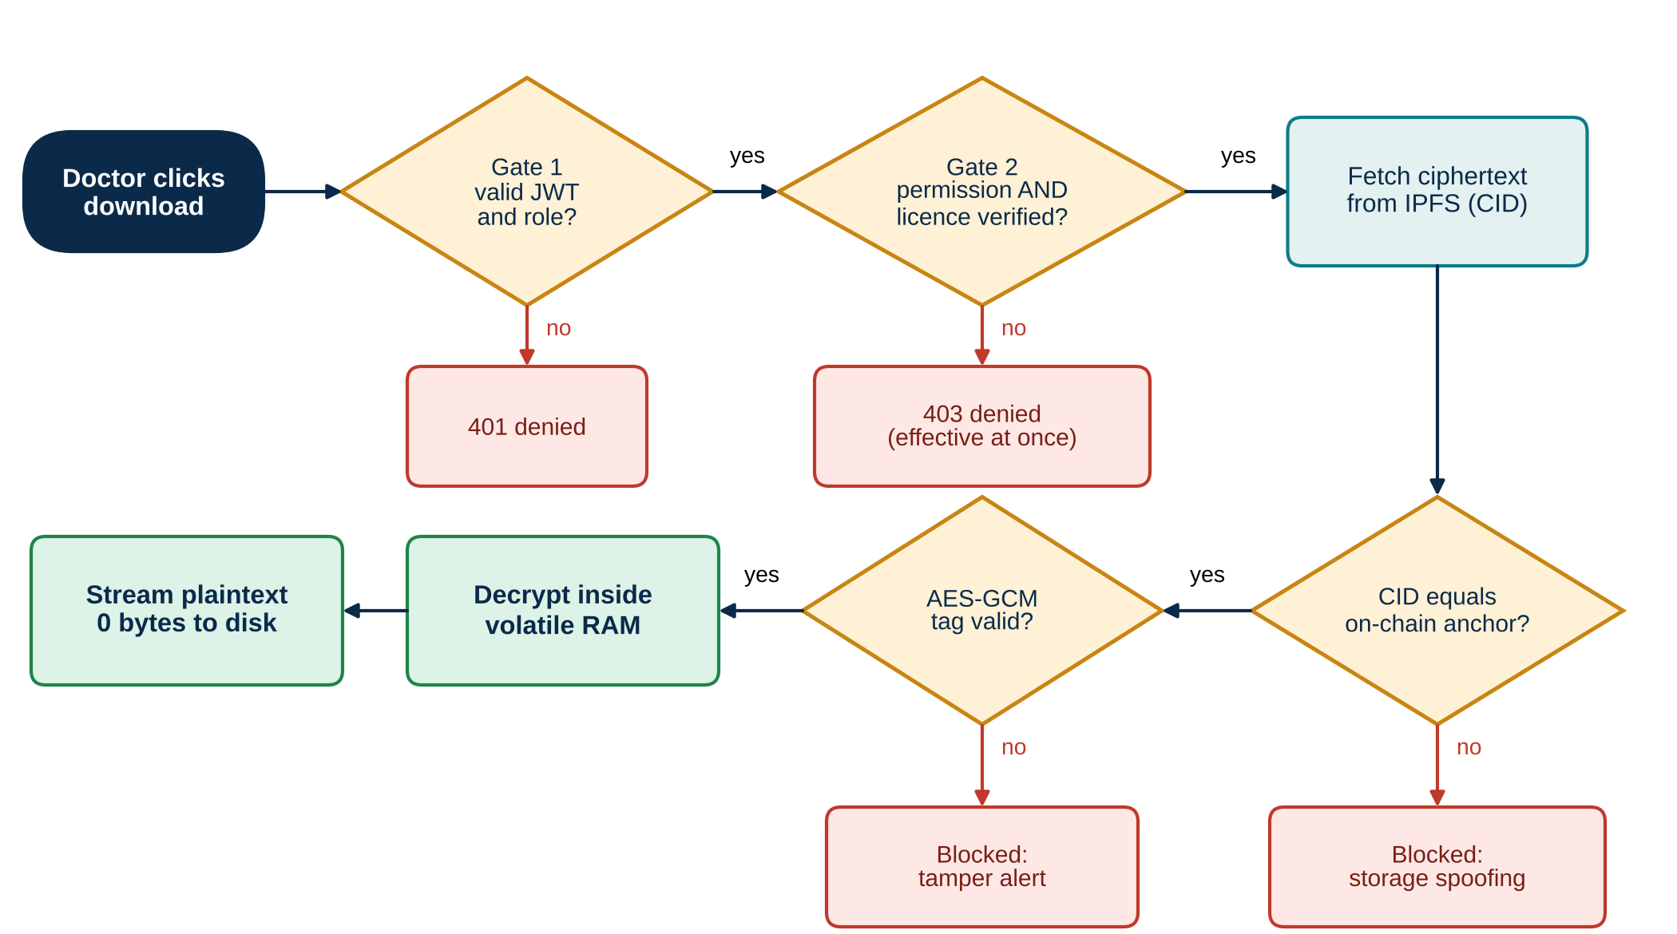
Fig. 5.1: Flow of the dual-gate decrypt-and-stream method
The two integrity checks guard different places. The GCM tag detects a change to the file bytes or the tag. The CID comparison detects a swapped pointer, where a storage node returns a different but internally valid file. A response also carries Cache-Control: no-store, so browsers and proxies do not keep a copy either.
Module 5: Access management and licence governance
Patients pick a verified doctor from a directory and grant access to one record or to all of their records. The administrator console lists every account and has a button to verify or revoke a doctor's licence. The gateway keeps a share list on each record, and the contract keeps the permission table. The design treats the contract as the authority and the share list as a convenience copy for fast listing.
Implementation status
To keep the report accurate, Table 5.1 states what is complete and what is only specified or benchmarked.
Table 5.1: Implementation status of each component
Component | Status | Note
MedicalRecord contract and unit tests | Complete | 11 test cases; gas measured (Section 7.3).
Wallet challenge login with nonce rotation | Complete | Replay and wrong-signer cases tested end to end.
AES-256-GCM encryption, IPFS pinning | Complete | Mock CID fallback when no Pinata token is set.
In-memory decrypt and stream, no disk write | Complete | Uploads use memory storage; temp folder stayed unchanged in the demo.
GCM tag verification on download | Complete | A flipped bit returns an error and no plaintext.
Gate 2 reads the contract at download time | Specified and benchmarked | The route currently checks the gateway share list; the on-chain call is the next integration step.
CID versus on-chain anchor comparison | Specified and benchmarked | Not yet in the download route.
Licence check inside the contract's grant and read paths | Specified | Registry exists; the enforcement hook is still to be added.
Per-doctor key wrapping | Future work | Gateway still holds the file keys.
5.2 Testing
Testing had four parts, each aimed at one objective from Section 2.3.
Smart contract unit tests. The Hardhat suite has 11 cases. They cover deployment, doctor registration and verification, rejection of verification by a non-owner, grant and revoke, rejection of self-authorisation, record upload by a patient and by an authorised doctor, rejection of an unauthorised doctor, isolation between patients and ownership transfer. The disclosure form records all 11 as passing.
Gas measurement. The contract was compiled with solc 0.8.20 (optimizer on, 200 runs) and every public function was called once on a local Ganache EVM with Shanghai rules. The gasUsed field of each receipt was recorded.
End-to-end API test. A script signed in as a patient and as a doctor with Hardhat development keys, and then exercised the real gateway routes for upload registration, share, download, revoke and a tampered file. IPFS was replaced by a small local HTTP server that returns stored ciphertext by CID, and the gateway ran in its in-memory mode. The result is in Table 6.1.
Algorithm benchmarks. scripts/run_patent_experiments.py generates 1,000 synthetic records (2 KB to about 1 MB, mean 230 KB) across 100 patients and 25 doctors, and then runs three experiments. In the first, 100 verified records are fetched and decrypted through a disk-caching proxy and through the memory path, with latency and bytes written recorded. In the second, 500 integrity trials are split into four equal groups: genuine requests, a single flipped ciphertext bit, a changed tag and a spoofed CID. In the third, a cached permission check with lifetimes from 60 to 900 seconds is compared with a live check. The script uses fixed random seeds. I ran it a second time on a different machine to see how much the timing results depend on the hardware (Section 7.1).
CHAPTER 6
PROJECT DEMONSTRATION
The prototype was run end to end with the gateway on port 5055 in in-memory mode, the production build of the React portals pointing at it, and a script standing in for the wallet. The script signed with the public Hardhat development keys for the patient, doctor and admin accounts. Table 6.1 lists the steps and what each returned, and the times are measured on the gateway at the client.
Table 6.1: End-to-end run of the gateway API
# | Step | Result | Time (ms)
1 | Patient wallet sign-in | Accepted, role patient | 96.7
2 | Doctor wallet sign-in | Accepted, role doctor, verified | 20.6
3 | Replay of a captured login signature | HTTP 401, rejected | -
4 | Login signed by a different wallet | HTTP 401, rejected | -
5 | AES-256-GCM encryption of a 115 KB file | Ciphertext 115 KB, 16-byte tag | 1.1
6 | Register record metadata | HTTP 201 | 8.2
7 | Doctor downloads before any grant | HTTP 403, denied | 7.2
8 | Patient grants access to the doctor | HTTP 200 | 6.1
9 | Doctor downloads after the grant | HTTP 200, bytes identical to the original | 35.0
10 | Patient revokes the doctor | HTTP 200 | 4.8
11 | Doctor downloads right after the revoke | HTTP 403, denied | 3.8
12 | Download of a record with one flipped ciphertext bit | HTTP 500, tag check failed, no plaintext sent | 7.0
13 | Download without a session token | HTTP 401, denied | -
14 | New files in the server temp folder | 0 | -
Steps 3 and 4 show that a captured signature is useless and that a signature from the wrong wallet is refused. Steps 7 to 11 show the access cycle: denied, granted, then denied again on the first request after the revoke. Step 12 shows that a damaged file never produces output, and step 14 shows that the server temp folder was left unchanged by the downloads.
Figure 6.1 shows the same cycle in the portals. The patient's overview and vault list the encrypted records with their IPFS identifiers, the doctor directory shows the doctors that can receive a grant, and after the grant the doctor's portal lists the shared records with a decrypt-and-view button. Figure 6.2 shows the administrator console, where licences can be verified or revoked.
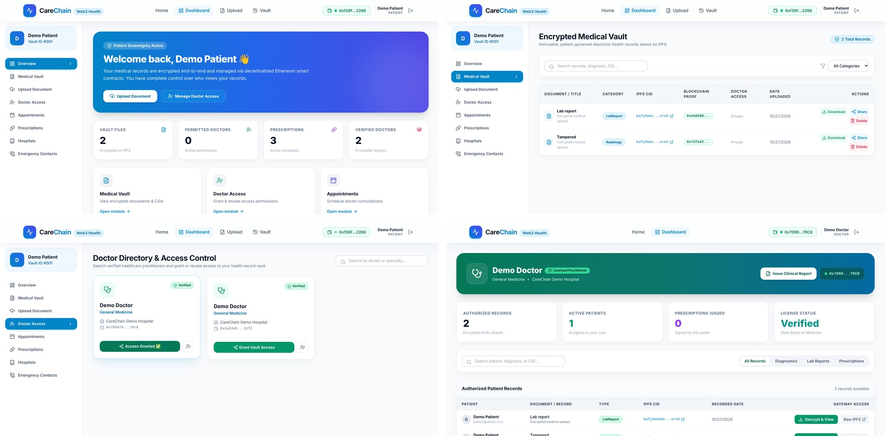
Fig. 6.1: Patient and doctor portals of the working prototype
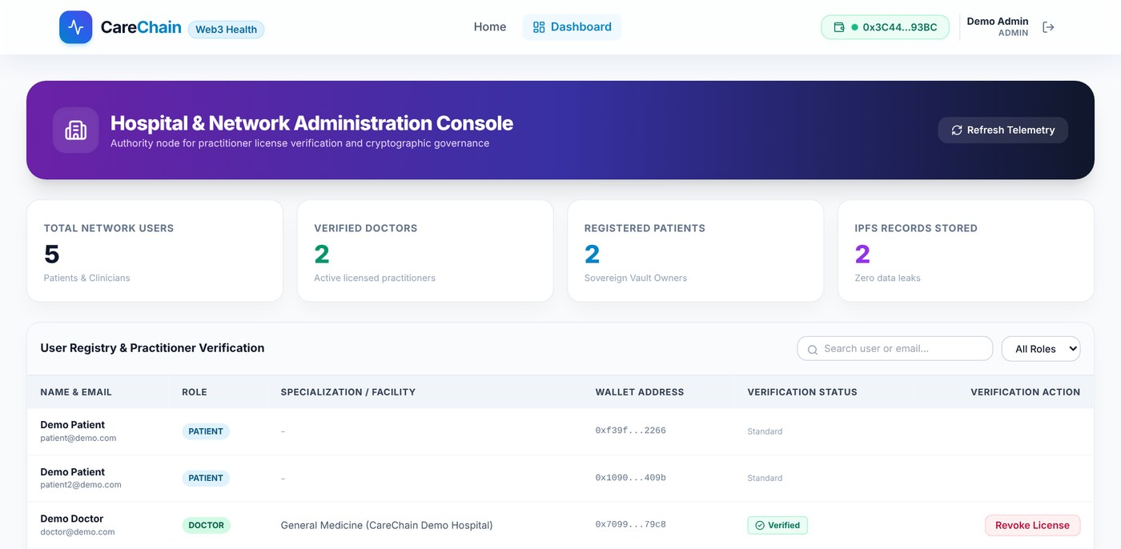
Fig. 6.2: Hospital administration console
CHAPTER 7
RESULT AND DISCUSSION (COST ANALYSIS)
7.1 Processing Latency and Disk Residue
Figure 7.1 compares a disk-caching proxy, which writes the ciphertext and then the plaintext to a temporary folder, with the in-memory path. Run A is the result recorded on the author's laptop. Run B is a second run of the same script on a different machine. The absolute times differ a lot between the two machines, because disk speed differs, but the direction does not: the memory path is faster in both runs and writes nothing.
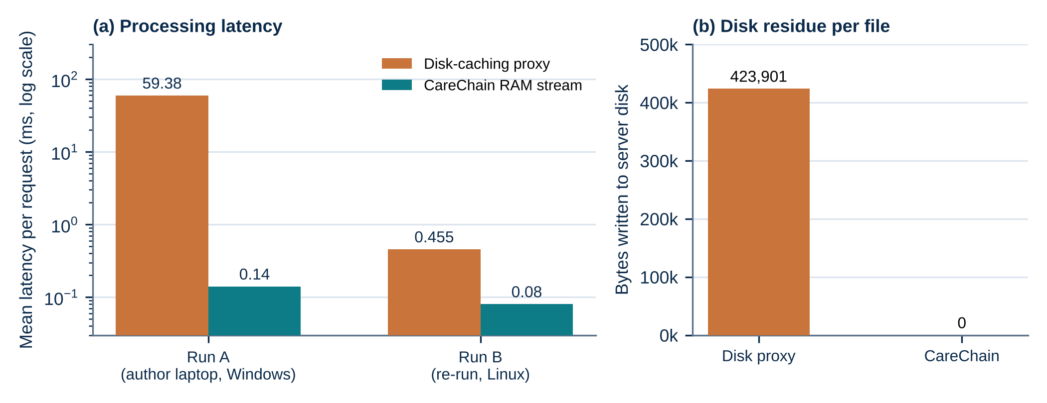
Fig. 7.1: Processing latency and disk residue
Table 7.1 gathers the numbers. The disk residue is the same in both runs. The proxy wrote 423,901 bytes per file on average, which is the encrypted copy plus the decrypted copy, while the memory path wrote none. These timings cover the cryptographic work and the local gate. A live contract query adds one network round trip to a node, and that time was not measured in this benchmark.
Table 7.1: Benchmark summary
Measure | Disk-caching proxy | CareChain memory path | Note
Mean latency, Run A (ms) | 59.38 | 0.14 | Author laptop, 100 records
Mean latency, Run B (ms) | 0.455 | 0.080 | Second machine, same script
Bytes written to disk per file | 423,901 | 0 | Same in both runs
Integrity trials accepted correctly | - | 125 of 125 | Genuine requests
Integrity attacks rejected | - | 375 of 375 | Bit flip, tag change, CID spoof
Requests served after revoke | 48.8% to 50.9% | 0% | Cache 60 to 900 s versus live check

7.2 Integrity and Revocation
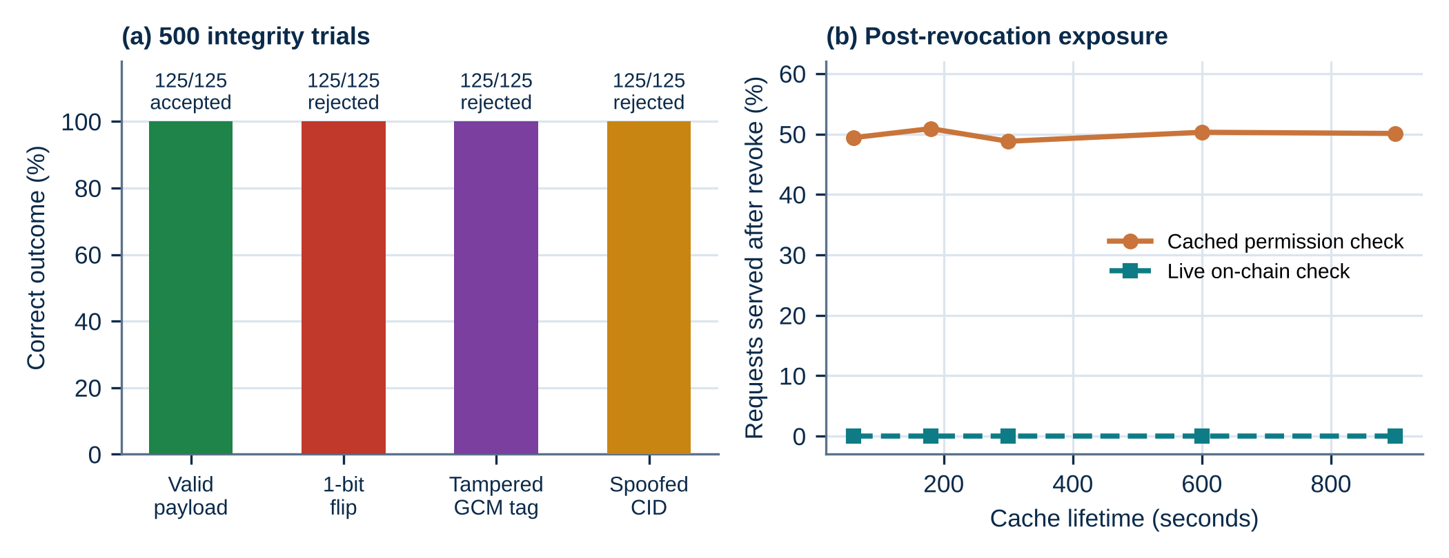
Fig. 7.2: Integrity trials and post-revocation exposure
In 500 integrity trials, all 125 genuine requests were accepted, and all 375 attacks were rejected: 125 single-bit flips, 125 changed tags and 125 spoofed CIDs. There were no false negatives and no false positives. The first two attack types are caught by the AES-GCM tag, and the spoofed CID is caught only by the on-chain comparison, which is why both checks are kept.
For revocation, a cached permission check was modelled with lifetimes from 60 to 900 seconds. A request that arrives after the revoke is served from the cache about half of the time (48.8% to 50.9% across the five lifetimes), because the revoke and the request fall at random points inside the cache window. A live check serves none. The zero for the live check follows from how it works, since the contract is read on every request, so this experiment shows the size of the problem it removes and does not measure a surprising result.
7.3 Cost Analysis
Table 7.2 and Figure 7.3 give the gas used by each function, measured as described in Section 5.2. Uploading a record is the most expensive call, because it writes the record's strings to storage. A permission grant is cheap, and a revoke is cheaper still.
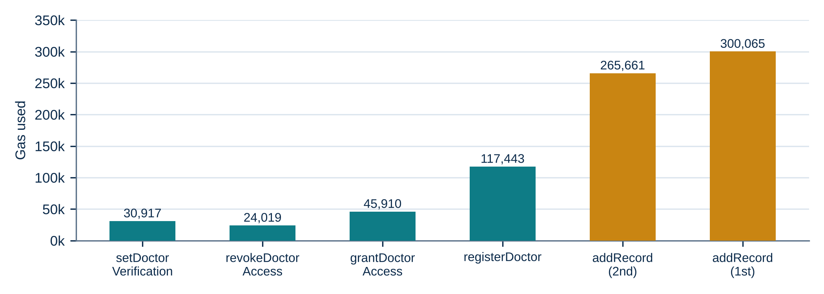
Fig. 7.3: Gas used by each contract function
Table 7.2: Gas used and cost at a stated gas price
Function | Gas used | Native token at 30 gwei | Illustrative cost
Deploy the contract (once) | 1,277,853 | 0.0383 | about US$0.0077
registerDoctor | 117,443 | 0.0035 | about US$0.0007
setDoctorVerification | 30,917 | 0.0009 | about US$0.0002
grantDoctorAccess | 45,910 | 0.0014 | about US$0.0003
revokeDoctorAccess | 24,019 | 0.0007 | about US$0.0001
addRecord (first for a patient) | 300,065 | 0.0090 | about US$0.0018
addRecord (later records) | 265,661 | 0.0080 | about US$0.0016
The last column is only an illustration. It assumes a gas price of 30 gwei and a token price of US$0.20, and both of those move with the market, so the real cost should be recomputed from the current values with cost = gas x gas price x token price. What does not move is that the numbers do not depend on file size, since only the CID and a few short strings are stored. Heavy data costs nothing in gas because it sits on IPFS. The IDF quotes about 82,000 gas for a record upload. Direct measurement of the current contract gave about 300,000, so this report uses the measured values.
Off-chain costs are small too. Encrypting the 115 KB test file took about 1.1 ms on the gateway, and pinning is the only recurring storage cost, which is usually small for text and image records of this size.
7.4 Comparison with Related Work
Table 7.3 compares the features of CareChain with the closest works in the review. A dash means the feature was not reported in the source that was read. The last row marks what is implemented and what is only designed, in line with Table 5.1.
Table 7.3: Feature comparison with related work
Feature | MedRec [1] | Reen [5] | Romel [7] | Patent [9] | CareChain
Patient grant and revoke | Yes | Yes | Yes | Yes | Yes
Encrypted file off-chain | - | Yes (IPFS) | Yes | - | Yes (IPFS)
Doctor licence registry | - | - | - | Trusted issuer | Yes (contract)
Live check at decrypt time | - | - | - | - | Designed, benchmarked
No plaintext on server disk | - | - | - | - | Yes
Two-part integrity check | - | - | - | - | Tag: yes; CID: designed
Wallet challenge login | - | - | - | - | Yes
7.5 Discussion and Limitations
The results support three of the five objectives with measurements: no disk residue, immediate refusal after a revoke in the API run, and detection of every tampering trial. They also show where the work stops, and the limits below matter for any claim made from it.
- The download route currently checks the gateway's share list. The contract call and the CID comparison are tested in the benchmark script and not yet in the route, so the live-gate claim describes the designed method.
- The contract stores the doctor registry but does not yet refuse a grant to an unverified address or a read by a de-verified one. The licence rule therefore still needs an enforcement hook in the contract or in the gateway call.
- The gateway generates and stores the file keys, so it can read every file. The description 'end to end' therefore applies to the network and to IPFS, not to the gateway. Wrapping each key to the doctor's public key is the fix.
- The benchmarks use synthetic records, a simulated permission table and one machine at a time. The revocation experiment models the cache and does not observe a real deployment.
- Gas was measured on a local EVM. Public-network gas and confirmation times will differ and were not measured.
7.6 Aspects Proposed for Protection
The IDF names four aspects for protection. Table 7.4 sets each one beside what the prototype does today. This is an engineering status check and not legal advice. The IDF describes the live contract call as part of the method, and the table shows that this part is still to be built.
Table 7.4: Aspects proposed for protection and their status
Aspect in the IDF | What the prototype does today | Status
1. Dual-gate decrypt-and-stream | Session check, in-memory decryption and streaming, and the GCM tag check work. The live contract read and the on-chain CID comparison are benchmarked but not in the route. | Partly implemented
2. Verified-practitioner gating in the contract | The doctor registry and permission mapping exist. The contract does not yet refuse a grant to an unverified address, and de-verification does not yet cut reads across all vaults. | Designed
3. Dual integrity verification | The 16-byte GCM tag is verified on every download. The comparison of the CID with the on-chain anchor is benchmarked only. | Partly implemented
4. Passwordless login with nonce rotation | EIP-191 signature over a timestamped 256-bit challenge, nonce rotated on success, replay rejected in the API run. | Implemented and tested
The general idea of patient-controlled blockchain records with IPFS is already well covered, as Section 2.1 shows. A registered patent agent must confirm whether any of the four aspects is novel and non-obvious.
CHAPTER 8
CONCLUSION
CareChain shows that a patient-controlled record system can be built from ordinary parts and can answer, with tests, the four problems that motivated it. The contract keeps who may read what, IPFS keeps only unreadable bytes, wallet sign-in removes passwords, and the download path decrypts in memory so that no readable copy is left behind. In the prototype runs, a doctor was denied before a grant, served after it and denied again on the first request after a revoke, a replayed login failed, and a damaged file released nothing. In the benchmarks, the memory path wrote no bytes to disk and every tampering and spoofing trial was caught. A record upload costs about 300,000 gas whatever the file size.
Of the four aspects named in the invention disclosure form, passwordless login with nonce rotation is implemented and tested, in-memory streaming and the tag check are implemented, and the live contract gate and licence enforcement remain to be integrated.
The work is also honest about its edges. The live contract query, the on-chain address comparison and the licence enforcement are designed and benchmarked, but they are not yet in the download route, and the gateway still holds the file keys.
Future Work
- Wire the contract read into the download route, deny by default when the chain cannot be reached, and re-run the end-to-end test with the real call included.
- Add the licence check to the contract's grant and read paths so that a de-verified doctor loses access to every patient at once.
- Wrap each file key to the doctor's public key, so the gateway no longer holds readable keys, and remove the wrapped key on revocation.
- Add an event-driven reconciliation service that keeps the share list equal to the chain and denies access when they differ.
- Log read events, support time-limited grants and add a break-glass emergency path with automatic patient notice.
- Deploy on a public test network, measure real gas and confirmation times, and test with realistic record sets. File a provisional patent after review by a registered agent.
CHAPTER 9
REFERENCES
- A. Azaria, A. Ekblaw, T. Vieira and A. Lippman, "MedRec: Using blockchain for medical data access and permission management," in Proc. 2nd Int. Conf. Open and Big Data (OBD), Vienna, Austria, 2016, pp. 25-30.
- Q. Xia, E. B. Sifah, K. O. Asamoah, J. Gao, X. Du and M. Guizani, "MeDShare: Trust-less medical data sharing among cloud service providers via blockchain," IEEE Access, vol. 5, pp. 14757-14767, 2017.
- A. Dubovitskaya, Z. Xu, S. Ryu, M. Schumacher and F. Wang, "Secure and trustable electronic medical records sharing using blockchain," in AMIA Annual Symposium Proceedings, vol. 2017, pp. 650-659, 2017.
- A. Shahnaz, U. Qamar and A. Khalid, "Using blockchain for electronic health records," IEEE Access, vol. 7, pp. 147782-147795, 2019.
- G. S. Reen, M. Mohandas and S. Venkatesan, "Decentralized patient centric e-health record management system using blockchain and IPFS," in Proc. IEEE Conf. Inf. Commun. Technol. (CICT), 2019, doi: 10.1109/CICT48419.2019.9066212.
- I. C. A. Pilares, S. Azam, S. Akbulut, M. Jonkman and B. Shanmugam, "Addressing the challenges of electronic health records using blockchain and IPFS," Sensors, vol. 22, no. 11, art. 4032, 2022.
- T. H. Romel, K. K. Paul, T. I. Ruhan, M. R. Mim and A. S. M. L. Hoque, "A patient-centric blockchain framework for secure electronic health record management: Decoupling data storage from access control," arXiv:2511.17464, 2025.
- T. Kenaza, I. Debicha, Y. Fares, M. Sehaki and S. Messai, "A secure and interoperable architecture for electronic health record access control and sharing," arXiv:2602.20830, 2026.
- "Patient-empowered data management: A secure blockchain architecture with decentralized ownership," U.S. Patent 12,235,984 B1.
- W. A. Yoon and A. Casella, "Blockchain for managing access to medical data," U.S. Patent 11,244,059 B2.
- "Inter-hospital electronic medical record access authentication protocol based on blockchains," U.S. Patent 12,292,997 B2.
- H. Tang et al., "Block chain-based medical electronic medical record distributed management system and preparation method thereof," Chinese Patent CN 112863629 B.
- "Patient authorized medical information storage and access system," U.S. Patent 11,862,304 B1, Health2047, Inc.
- J. Benet, "IPFS - Content addressed, versioned, P2P file system," arXiv:1407.3561, 2014.
- M. Dworkin, "Recommendation for block cipher modes of operation: Galois/Counter Mode (GCM) and GMAC," NIST Special Publication 800-38D, 2007.
APPENDIX A - Sample Code
A.1 AES-256-GCM helpers (backend/utils/encrypt.js, shortened)
export function encryptBuffer(buffer) {
const key = crypto.randomBytes(32); // 256-bit key, new for every file
const iv = crypto.randomBytes(12); // 96-bit IV, the size GCM expects
const cipher = crypto.createCipheriv('aes-256-gcm', key, iv);
const encrypted = Buffer.concat([cipher.update(buffer), cipher.final()]);
const tag = cipher.getAuthTag(); // 16-byte authentication tag
return { encrypted, key: key.toString('hex'),
iv: iv.toString('hex'), tag: tag.toString('hex') };
}

// decipher.final() throws if the tag does not match, so a damaged
// file never produces plaintext.
A.2 Permission and licence functions (contracts/MedicalRecord.sol, shortened)
function setDoctorVerification(address _doctor, bool _isVerified) external onlyOwner {
require(doctors[_doctor].isRegistered, "Doctor is not registered");
doctors[_doctor].isVerified = _isVerified;
emit DoctorVerificationUpdated(_doctor, _isVerified);
}

function grantDoctorAccess(address _doctor) external {
require(_doctor != address(0), "Invalid doctor address");
require(_doctor != msg.sender, "Cannot authorize self");
doctorPermissions[msg.sender][_doctor] = true;
emit AccessGranted(msg.sender, _doctor, block.timestamp);
}

function revokeDoctorAccess(address _doctor) external {
doctorPermissions[msg.sender][_doctor] = false;
emit AccessRevoked(msg.sender, _doctor, block.timestamp);
}
A.3 Download route (backend/routes/recordRoutes.js, shortened)
router.get('/:id/download', async (req, res) => {
const record = await Record.findById(req.params.id);
// Gate: owner, shared doctor or admin (share list in the current prototype)
if (!isOwner && !isSharedDoctor && !isAdmin)
return res.status(403).json({ error: 'Access denied.' });
const ipfs = await axios.get(gatewayUrl + record.cid, { responseType: 'arraybuffer' });
const plain = decryptBuffer(Buffer.from(ipfs.data), record.key, record.iv, record.tag);
res.setHeader('Cache-Control', 'no-store, no-cache, must-revalidate, private');
return res.send(plain); // streamed from memory, nothing written to disk
});

